Sree narayana vidya mandir senior secondary school

Talap, Kannur-670 002.



COMPUTER SCIENCE

PROJECT REPORT

Certified that this project is the bonafide project report of Mr/Ms of ……………………………….standard XIIB with Register Number………………for the year 2026-2027.

Teacher-in-charge

Valued at the board examination

Examiners

1………………………………………….

2………………………………………….
Principal

Date………………………

PROJECT NAME

PROJECT MEMBERS

ACKNOWLEDGEMENT

I would like to express my sincere gratitude and thanks towards Mrs.Smitha Srinivasan, the Principal and Mrs.Deepika Jaidas , the Educational Officer of Sree Narayana Vidya Mandir, for the guidance and encouragement throughout my course and at the time of my project.

I am extremely grateful to Ms.Vipina M, Teacher, Department of Computer Science for her sincere and timely help and corporation during all the phases of my project.

I express my deepest gratitude and sincere thanks to Ms.Thushara Teacher, Department of Computer Science for her valuable guidance throughout the project.

Special mentions have to be made of Ms.Vineetha C R and Ms.Simna C V ,Ms. Vinduja K, Ms.Devika Teachers, Department of Computer Science for all their support and help rendered towards the fulfillment of the project.

Finally, but not the least, I would like to express my sincere gratitude towards my family members for all the help they given to me and also towards my friends for their support in the successful completion of the project.

CONTENTS

- INTRODUCTION

- WORKING ENVIRONMENT

- SYSTEM ANALYSIS

- SOURCE CODE

- SCREENS, INPUTS & OUTPUTS

- CONCLUSION

- BIBLIOGRAPHY

INTRODUCTION

The project entitled CAFE MANAGEMENT SYSTEM is developed using MySQL DBMS and Python connectivity using “mysql.connector” module.

Python is a flexible, portable, easy to modifiable and platform –independent language.so we are integrating MySQL with Python interface for executing any database applications. The input is fetched from the user using Python interface termed as the Front End Interface of the application. An application usually stores a lot of data in the form of a database permanently are called Back End Database.
The main objective of the application is to automate the existing system of manually maintain the records of books.
This project aims at the computerization of the book information management system. There are numerous advantages of computerization of this management system, like speed, efficiency, reliability & accessibility. This helps in making the system more sophisticated and user friendly. This helps in saving the precious time. Errors while handling the system can also be minimized.
The important modules used in the project are:
- Main menu
- create table
- insert record
- search record
- delete record
- update record
- view all

WORKING ENVIRONMENT

Software

Platform : Windows 10

Languages : Python , MYSQL

HARDWARE

Processor : Intel Celeron

Clock speed : 333 MHz

Ram : 4GB

Hard disk capacity : 80 GB

Bit specification : 64 Bits

Keyboard : Lenovo keys

Mouse : hpOptical

Display device : Lenovo TFT

SYSTEM ANALYSIS

Existing system

In the existing system, many of the operations are done manually. Manual system consumes lot of time and is quite inefficient. As the operations are done manually there are chances for clerical errors also.

Drawbacks

- Time-Consuming Process: Manually recording customer orders, preparing bills, and maintaining records takes more time.
- Human Errors: Mistakes may occur while calculating bills, recording orders, or managing stock.
- Difficulty in Maintaining Records: Maintaining large amounts of information in registers and notebooks can be difficult and confusing.
- Difficulty in Tracking Stock: Manually checking the availability of food items and ingredients takes time and may lead to stock shortages.
Proposed system

In the proposed system, we try to overcome all these issues of the existing system. This system is more users friendly and is easy to handle even for a novice user. As the code is flexible and effective, it is easy to enhance according to the customer requirement.

Mysql Table Structure

The MySQL table used for storing book details in this project is:

- Name of the Database:
- Table Name :
(here devrag need to change these idk have infos)
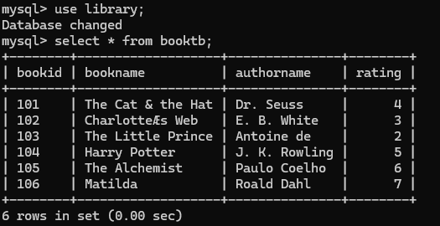

DEVRAG DON’T SKIP THIS PAGE

SOURCE CODE:

INPUT&
OUTPUT SCREENS
MAIN MENU

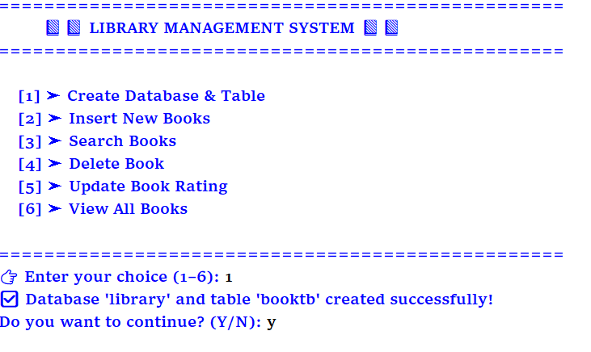DEVRAG CHANGE IT
PLS BRUh LOLL
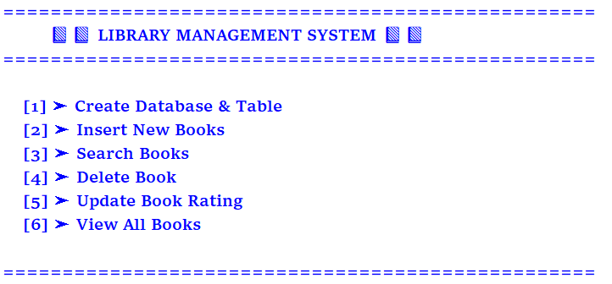
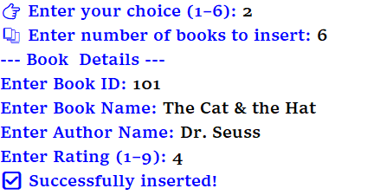

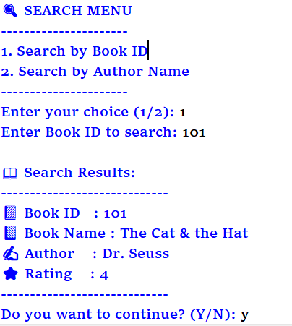

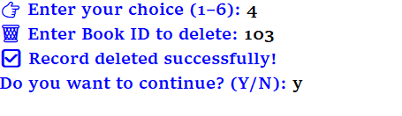
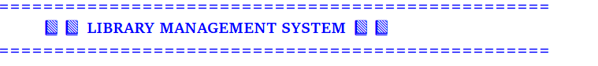
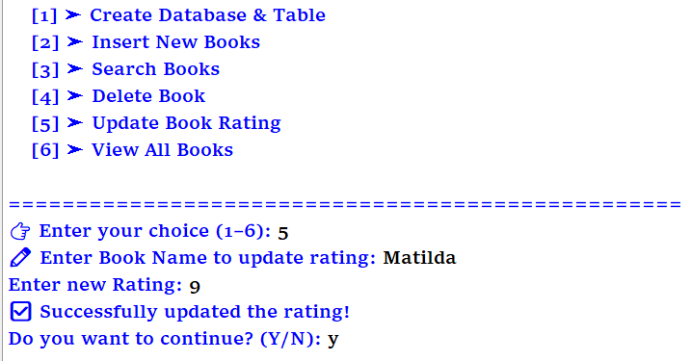
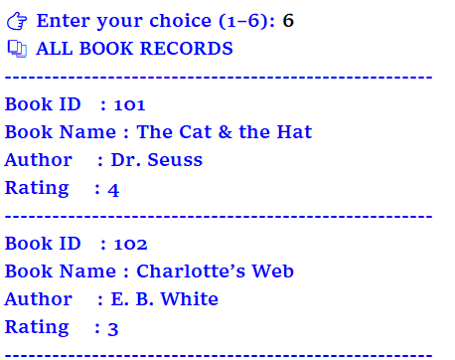

Have u done?

CONCLUSION

To conclude in total the computerized LIBRARY management system is widely accepted due to its menu driven feature, reliability and user-friendly options like:
- Create()
- Insert()
- Search()
- Delete()
- Update()
- View()
User friendly: The whole project is being menu driven makes it user friendly, it displays required messages wherever necessary.

Reliability: Software reliability is also defined as the probability that a software system fulfills its assigned task in a given environment for a predefined number of input cases, assuming that the hardware and the input are free of error.Software reliability concerns with how the program works in different solutions

Should I repeat to u to change this also ()

BIBLIOGRAPHY

- Computer Science With Python – Preethi Arora
- www.google.com
- www.wikipedia.com/Python
- Class Notes

IF U WANT CHANGE oR KEEP

